Chapter 4, Problem 96.

A resistance array is connected to a load resistor R and a 9-V battery as shown in Fig. 4.151.
- Find the value of R such that V_{o} = 1.8 V.
- Calculate the value of R that will draw the maximum current. What is the maximum current?

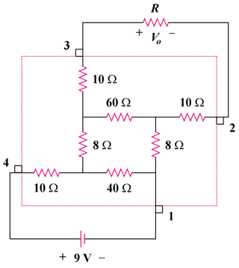

Figure 4.151
For Prob. 4.96.

